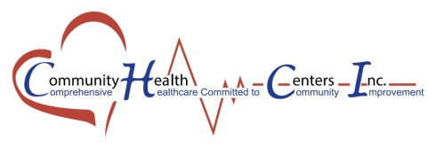
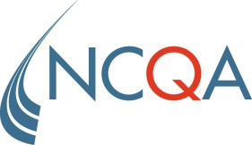

FOR IMMEDIATE RELEASE: FOR MORE INFORMATION:

March 21, 2016 Susan Geurin (405) 272-0476
Rosalyn Johnson (405) 769-3301 x1283

Community Health Centers, Inc.’s Mary Mahoney Memorial Health Center Site EARNS national recognition FOR
PATIENT-CENTERED CARE

NCQA Patient-Centered Medical Home™ standards emphasize enhanced care through
patient-clinician partnership

WASHINGTON, DC—The National Committee for Quality Assurance (NCQA) today announced that Mary Mahoney Memorial Health Center of Oklahoma City, Oklahoma has received NCQA Patient-Centered Medical Home (PCMH) Recognition for using evidence-based, patient-centered processes that focus on highly coordinated care and long‐term, participative relationships.

The NCQA Patient-Centered Medical Home is a model of primary care that combines teamwork and information technology to improve care, improve patients’ experience of care and reduce costs. Medical homes foster ongoing partnerships between patients and their personal clinicians, instead of approaching care as the sum of episodic office visits. Each patient’s care is overseen by clinician-led care teams that coordinate treatment across the health care system. Research shows that medical homes can lead to higher quality and lower costs, and can improve patient and provider reported experiences of care.

“NCQA Patient-Centered Medical Home Recognition raises the bar in defining high-quality care by emphasizing access, health information technology and coordinated care focused on patients,” said NCQA President Margaret E. O’Kane. “Recognition shows that Mary Mahoney Memorial Health Center has the tools, systems and resources to provide its patients with the right care, at the right time.”

To earn recognition, which is valid for three years, Mary Mahoney Memorial Health Center demonstrated the ability to meet the program’s key elements, embodying characteristics of the medical home. NCQA standards aligned with the joint principles of the Patient-Centered Medical Home established with the American College of Physicians, the American Academy of Family Physicians, the American Academy of Pediatrics and the American Osteopathic Association.
To find clinicians and their practices with NCQA PCMH Recognition, visit http://recognition.ncqa.org.
About NCQA
NCQA is a private, non-profit organization dedicated to improving health care quality. NCQA accredits and certifies a wide range of health care organizations. It also recognizes clinicians and practices in key areas of performance. NCQA’s Healthcare Effectiveness Data and Information Set (HEDIS®) is the most widely used performance measurement tool in health care. NCQA’s Web site (ncqa.org) contains information to help consumers, employers and others make more informed health care choices.

###

